LAB Logbook

Lab 1
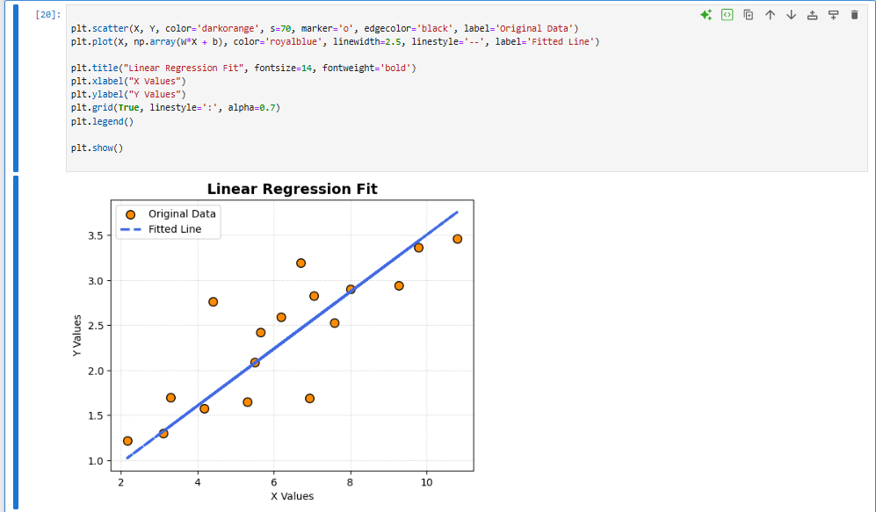
Lab 2
Task 1:
- Accuracy: 0.931
- MLP architectures
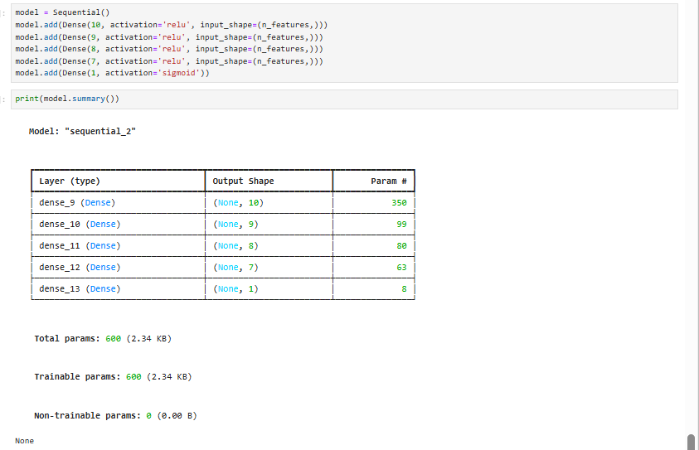
Task 2:
- O1 = 0.7877
- O2 = 0.7877

Lab 3
Test Accuracy
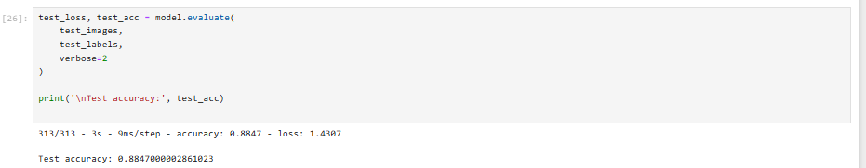
Model Summary
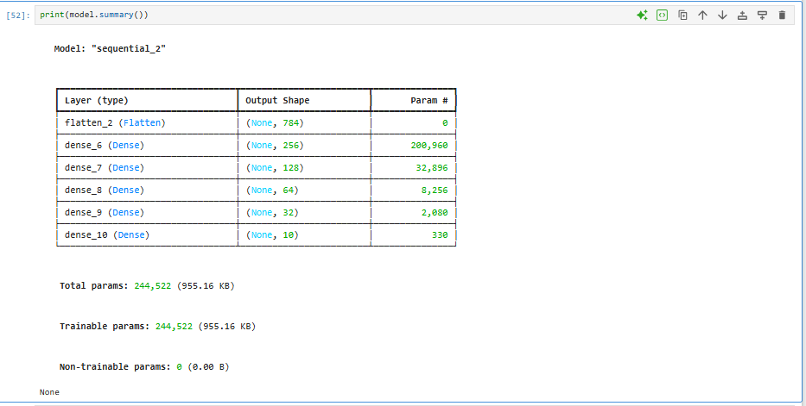

Lab 4
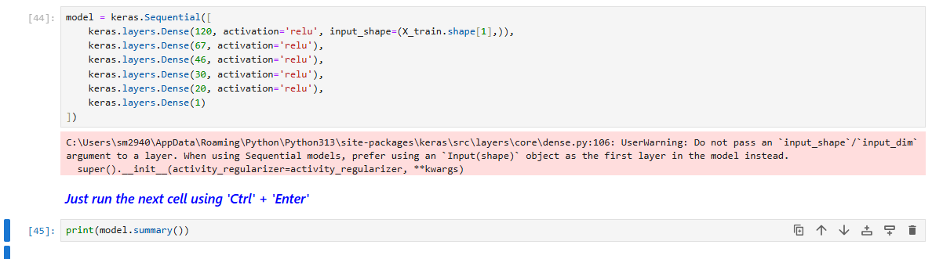
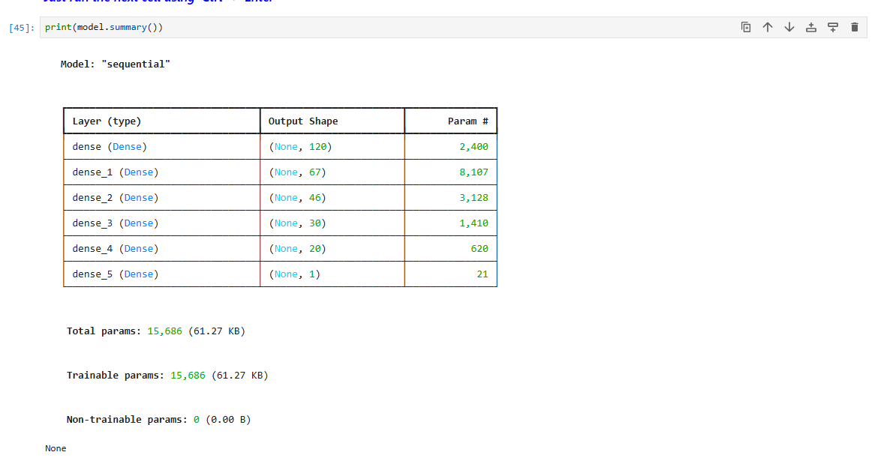
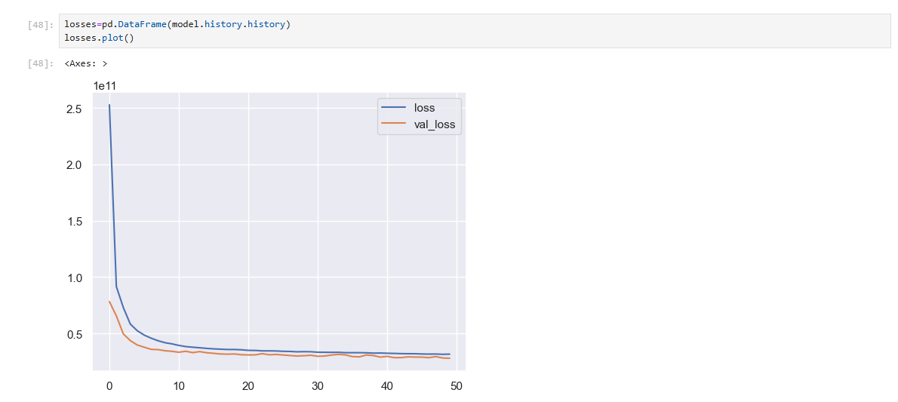
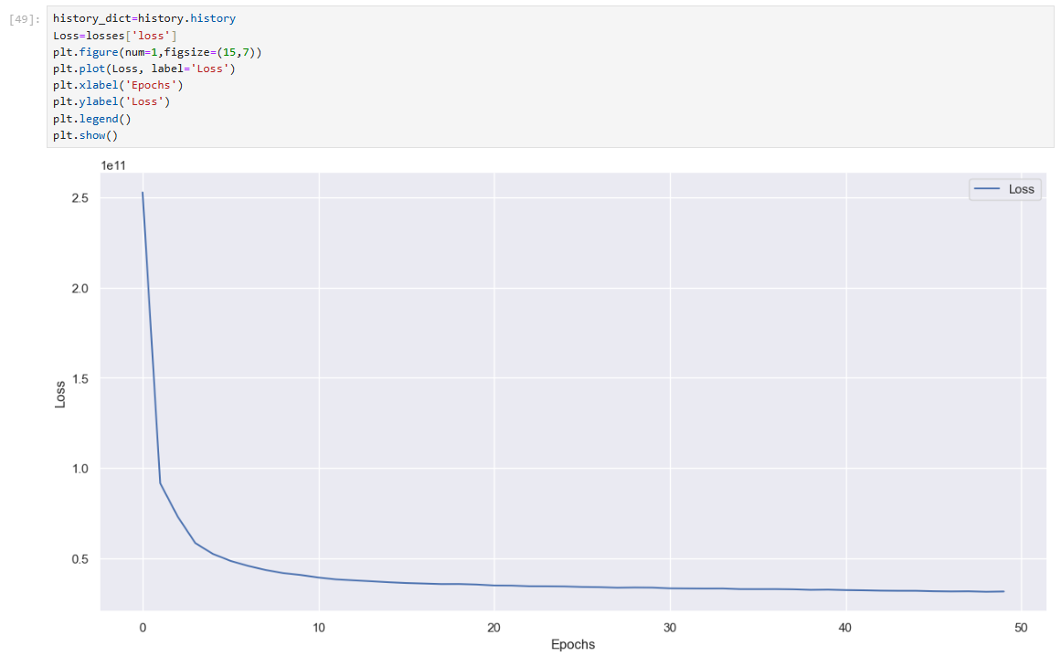
Lab 5

Lab 6

Lab 7

Lab 8

Lab 9

Lab 10

Lab 11

Lab 12

